Assignment 1

Java Review

Dhruvil Patel

S01215302

Cuyahoga Community College

Sept 30, 2021

## Classes

A Java class can be defined as a user-defined data type.

## Objects

An object is a real instance of a class that is created from the definition of a class.

The class has an object type. In order to instantiate an object, the new keyword is used.

## Java class Class and Object instantiation Example with 1 object

Defining a class called Employee in Java with object instantiation. In the code below, a class called Employee is defined and an object emp instantiated.

public class Employee {

int empno;

String ename;

float sal;

public static void main(String[] args) {

//Object Instantiation

Employee emp = new Employee();

//access the employee object properties using reference

// System.out.println(emp.empno + " | " + emp.ename + " | " + emp.sal);

//Changing state of object

emp.empno = 203;

emp.ename = "Jerry";

emp.sal = 4772;

//access the employee object properties using reference

System.***out***.println(emp.empno + " | " + emp.ename + " | " + emp.sal);

}

}

## Screenshot

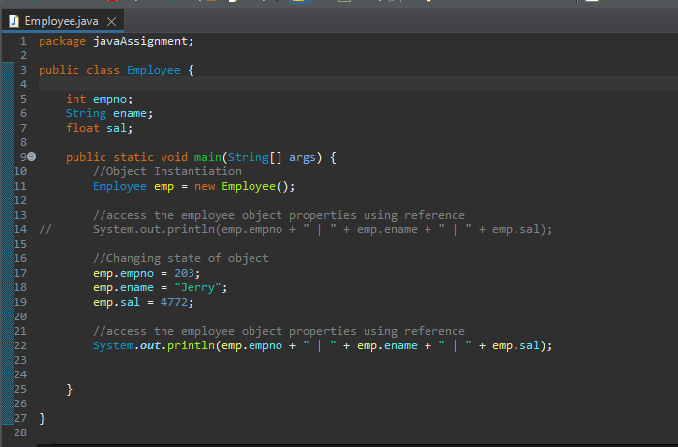

Output



## Java class Class and Object instantiation Example with 2 objects

Defining a class called Employee in Java with object instantiation. In the code below, a class called Employee is defined and an object emp1 instantiated.

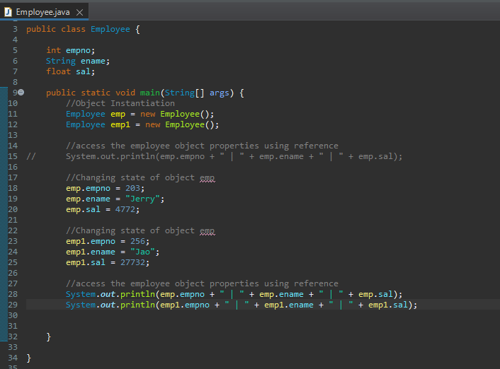

## Output



## Invoking Java Methods

A java method is a statement that is used to perform a specific task or operation.

Methods can or cannot contain a parameter.

The structure of a java method is as follows:

**public static int nameOfMethod(int a, int b) {**

**// body**

**}**

In the above example, public static is the modifier, int is the return type, nameOfMethod is the Method Name and int a, and int b are the method parameters.

## Method Invocation example

Code

package sumNumbers;

public class Main {

//Invoking a method

public int sumOfNumbers(int x, int y) {

int sum = x + y;

return sum;

}

public static void main(String[] args) {

// assigning values

int number1 = 160;

int number2 = 40;

//Object Instantiation

Main ob = new Main();

//Method call

int result = ob.sumOfNumbers(number1, number2);

System.***out***.println("The Result of the Addition is: " + result);

## Screenshots

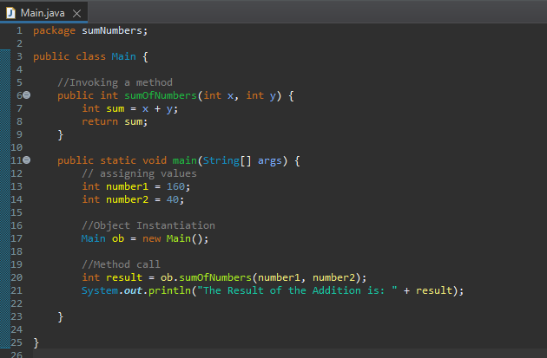

## Output

